**Experiment-5**

**Part A**

**Aim:** Simulation of Static Routing in Cisco Packet Tracer.

**Prerequisite:** Nil

**Outcome:** To impart knowledge of Computer Networking Technology

**Theory:**

Static routing is a fundamental concept in computer networking that plays a crucial role in the efficient and reliable transfer of data between network devices. In the context of Cisco Packet Tracer, a network simulation and visualization tool, static routing involves the manual configuration of routing tables on network devices, such as routers and switches. This theory explains the key concepts, benefits, and configuration of static routing within Cisco Packet Tracer.

Key Concepts:

1. Routing: Routing is the process of determining the path that network traffic should follow to reach its destination. In static routing, the routing path is manually configured by a network administrator and remains unchanged unless modified explicitly.

2. Routing Table: Each network device maintains a routing table that contains information about network destinations and the next-hop devices to reach them. In static routing, this table is manually configured.

3. Destination Network: It represents the target network or subnet that data packets need to reach. Each destination network is associated with a specific route.

4. Next-Hop: The next-hop device is the router or gateway responsible for forwarding data packets towards the destination network. In static routing, the next-hop is configured manually.

Benefits of Static Routing:

1. Simplicity: Static routing is easy to set up and manage, making it an ideal choice for smaller networks or for specific routing scenarios within larger networks.

2. Predictability: Since routes are manually configured, network administrators have full control over routing decisions, making the network's behaviour predictable.

3. Reduced Overhead: Static routing requires less processing power and overhead compared to dynamic routing protocols, which can be advantageous in resource-constrained environments.

4. Enhanced Security: Static routes are less susceptible to certain types of attacks, such as route poisoning, as they are not affected by dynamic routing protocol vulnerabilities.

**Procedure:**

1. Open Cisco Packet Tracer and simulate the sample topologies for Static Routing.

2. Perform Necessary Operation on Router to create and configure Static Routing.

3. Check the connectivity between the devices.

**Part – B**

**Steps:**

1) Open Cisco Packet Tracer and load your network topology containing the routers.

2) Click on the router from which you want to configure a static route to reach another network.

3) In the router's information panel, select the "Config" tab.

4) Look for the "Static" section in the configuration panel, and find an option to add a static route.

5) Click on the "Add" or "Edit" button to configure a new static route.

6) In the static route configuration window, enter the following information:

- Destination Network: The network or subnet you want to reach on the other router.

- Subnet Mask: The subnet mask for the destination network.

- Next Hop IP Address: The IP address of the interface on the neighbouring router that connects to the destination network.

7) After configuring the static route, find a "Save" or "Apply" button in the static route configuration window, and click it to save the changes.

8) Repeat the above steps for the other router, configuring a static route to reach the network on the first router.

**Output:**

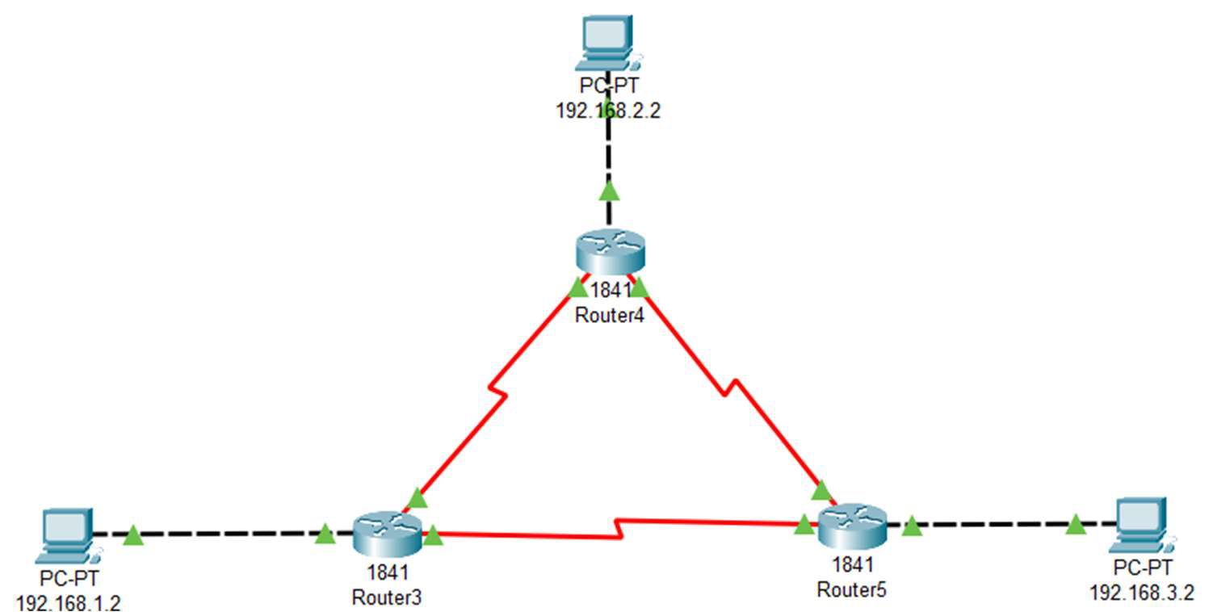

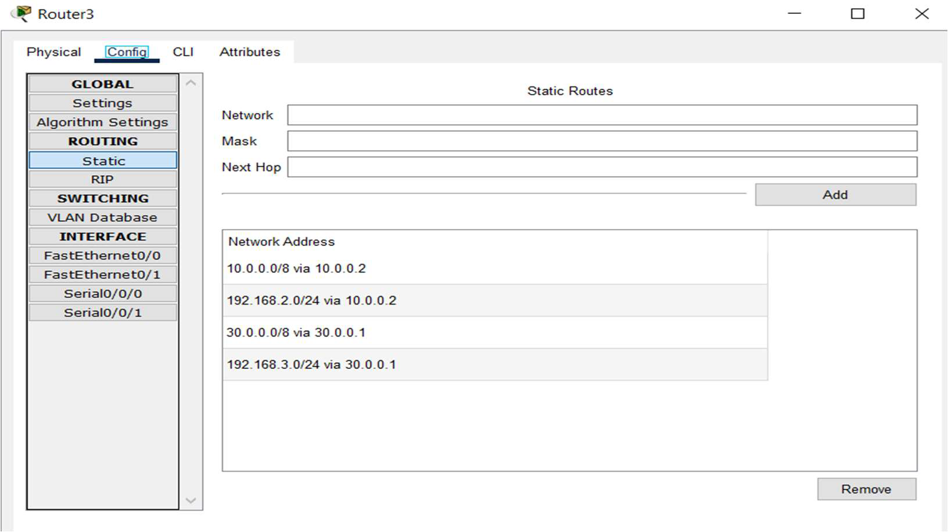

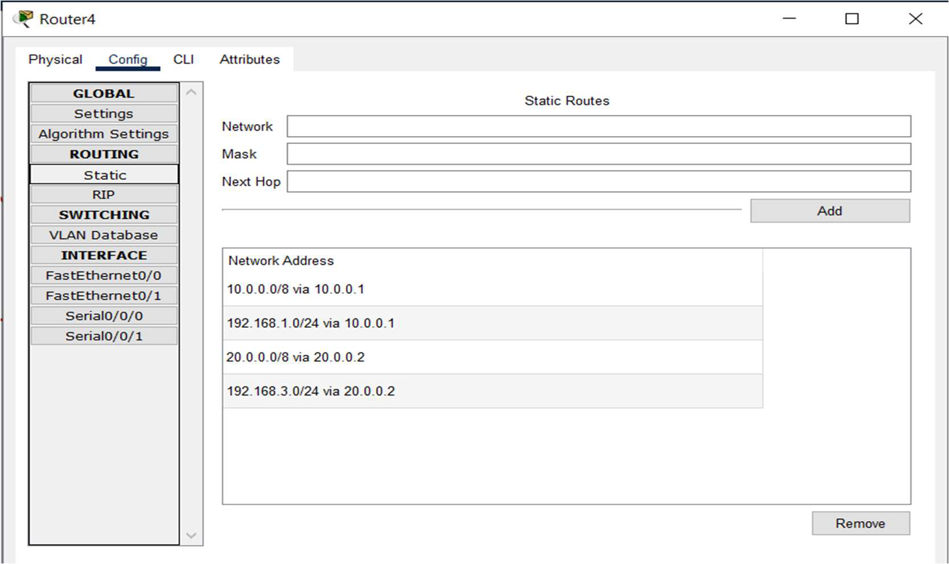

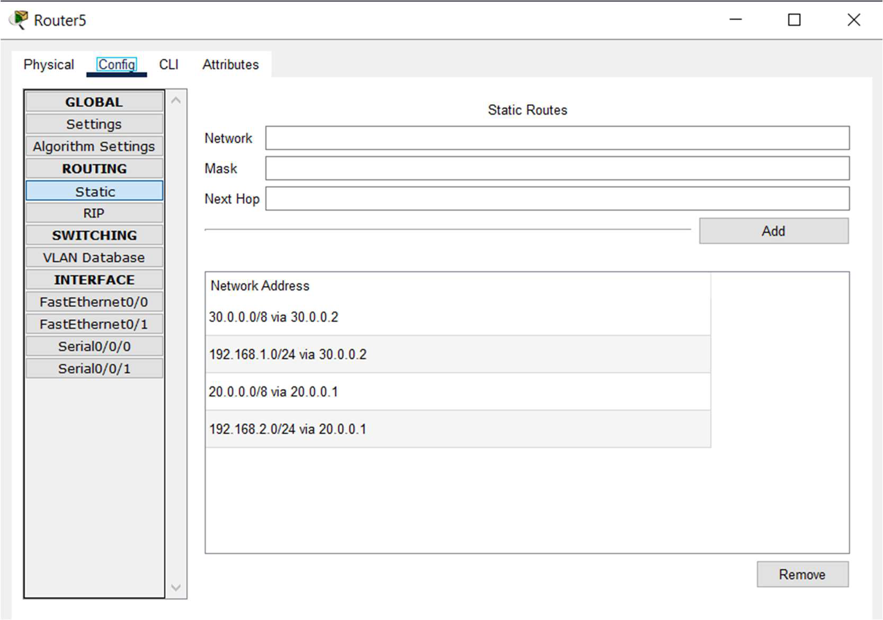

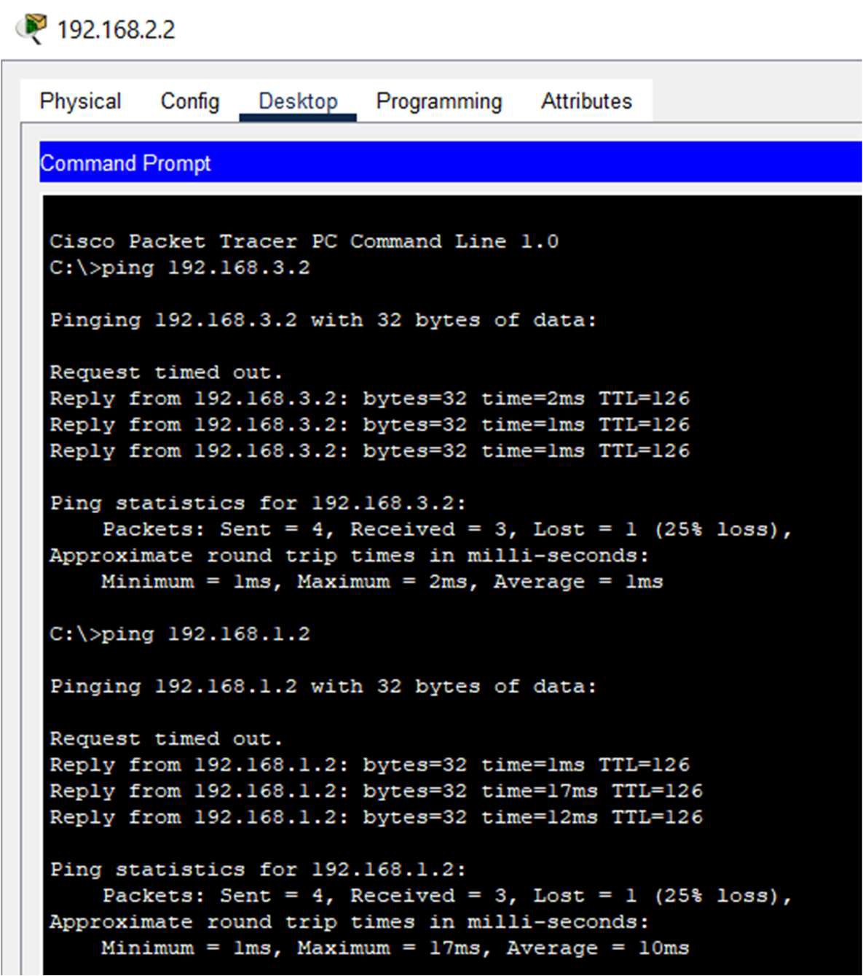

**Observation & Learning:**

1. Manual Configuration: One of the key observations pertains to the fact that static routing entails the manual setup of routing tables on network devices. In contrast to dynamic routing protocols, where routes are determined automatically, static routes necessitate explicit definition. This manual configuration affords a high degree of control over routing decisions.

2. Route Configuration: It was noted that the process of configuring static routes in Cisco Packet Tracer involves specifying the destination network or subnet, the subnet mask, and the next-hop device. This information is appended to the routing table on the router, enabling it to determine how to forward data packets to their intended destinations.

3. Use in Small Networks: Static routing is well-suited for smaller networks or specific routing scenarios within larger networks. It proves to be efficient and uncomplicated to set up, making it a practical choice when network complexity is relatively low.

4. Basic Configuration: I acquired knowledge of the fundamental steps for setting up static routes in Cisco Packet Tracer. This encompasses accessing the device's command line, entering global configuration mode, and adding static routes using the 'ip route' command.

5. Next-Hop Definition: A critical concept I grasped was the identification of the next-hop device. The next-hop signifies the router or gateway responsible for forwarding data packets to a specific destination network. I learned how to specify the next-hop when configuring static routes.

6. Resource Efficiency: Static routing exhibits relatively efficient resource usage, as it demands less processing power and overhead in comparison to dynamic routing protocols. This learning underscored the advantages of static routing in resource-constrained environments.

**Conclusion:**

In summary, the experience with Static Routing in Cisco Packet Tracer has emphasized the fundamental networking concept of manual route configuration and its significance in a variety of network scenarios. The ability to establish predictable routing paths by explicitly defining routing tables is a valuable skill for network administrators, particularly in small to medium-sized networks where resource efficiency and control are essential. The observations and practical knowledge gained through this exercise underscore the role of static routing in improving network stability, security, and efficiency, establishing it as an indispensable tool in network management and configuration.